**ASSIGNMENT-2**

**MODULE 7**

**AURORA**

**DONE BY**

**RANJITH KUMAR**

**TASKS:**

1. Create an AuroraDB Engine based RDS Database.

2. Create 2 Read Replicas in different availability zones for better

infrastructure availability.

STEP 1 : Open RDS from aws services

STEP 2 : Databases > Create database

STEP 3 : Select **Aurora** from engine type

STEP 4 : Select templates , credentials , instances class , network , storage , and needed details to create a database

STEP 5 : In Availabilty & durability section select **create an aurora replica**

STEP 5 : Aurora database is created

STEP 6 : Create an EC2 instances with linux based(Ubuntu)

STEP 7 : Select the security group of the database create a rule allowing mysql(3306)

STEP 8 : Connect to the instance and update it(**sudo apt-get update -y**)

STEP 9 : Install mysql server and client using the command :- **sudo apt install mysql-server mysql-client**

STEP 10 : Use the endpoint from RDS to connect.Command:- **sudo mysql -h(endpoint) -u(username) -p(password)**

STEP 11 : Database connected using writer endpoint

STEP 12 : Use commands :-

- **use aurora;**

- **show tables;**

- **CREATE TABLE employee (emp_id VARCHAR(20), first_name VARCHAR(20),last_name VARCHAR(20),primary_skills VARCHAR(20),location VARCHAR(20));**

- **describe employee;**

- **insert into employee values(1,"Tony","Stark","AWS","ABC");**

- **select * from employee;**

To check whether we can write in our database

STEP 13 : Now select the reader instance use the reader endpoint to connect to the database

STEP 14 :Use same commands used in writer instance to check its working. We cannot insert a data hence it’s a reader instance

STEP 15 :Writer and reader instance are connected and working

STEP 16 : Now select database cluster > actions > add reader

STEP 17 : One replica is created while creating the database now second replica is being created

STEP 18 : Two read replicas is created

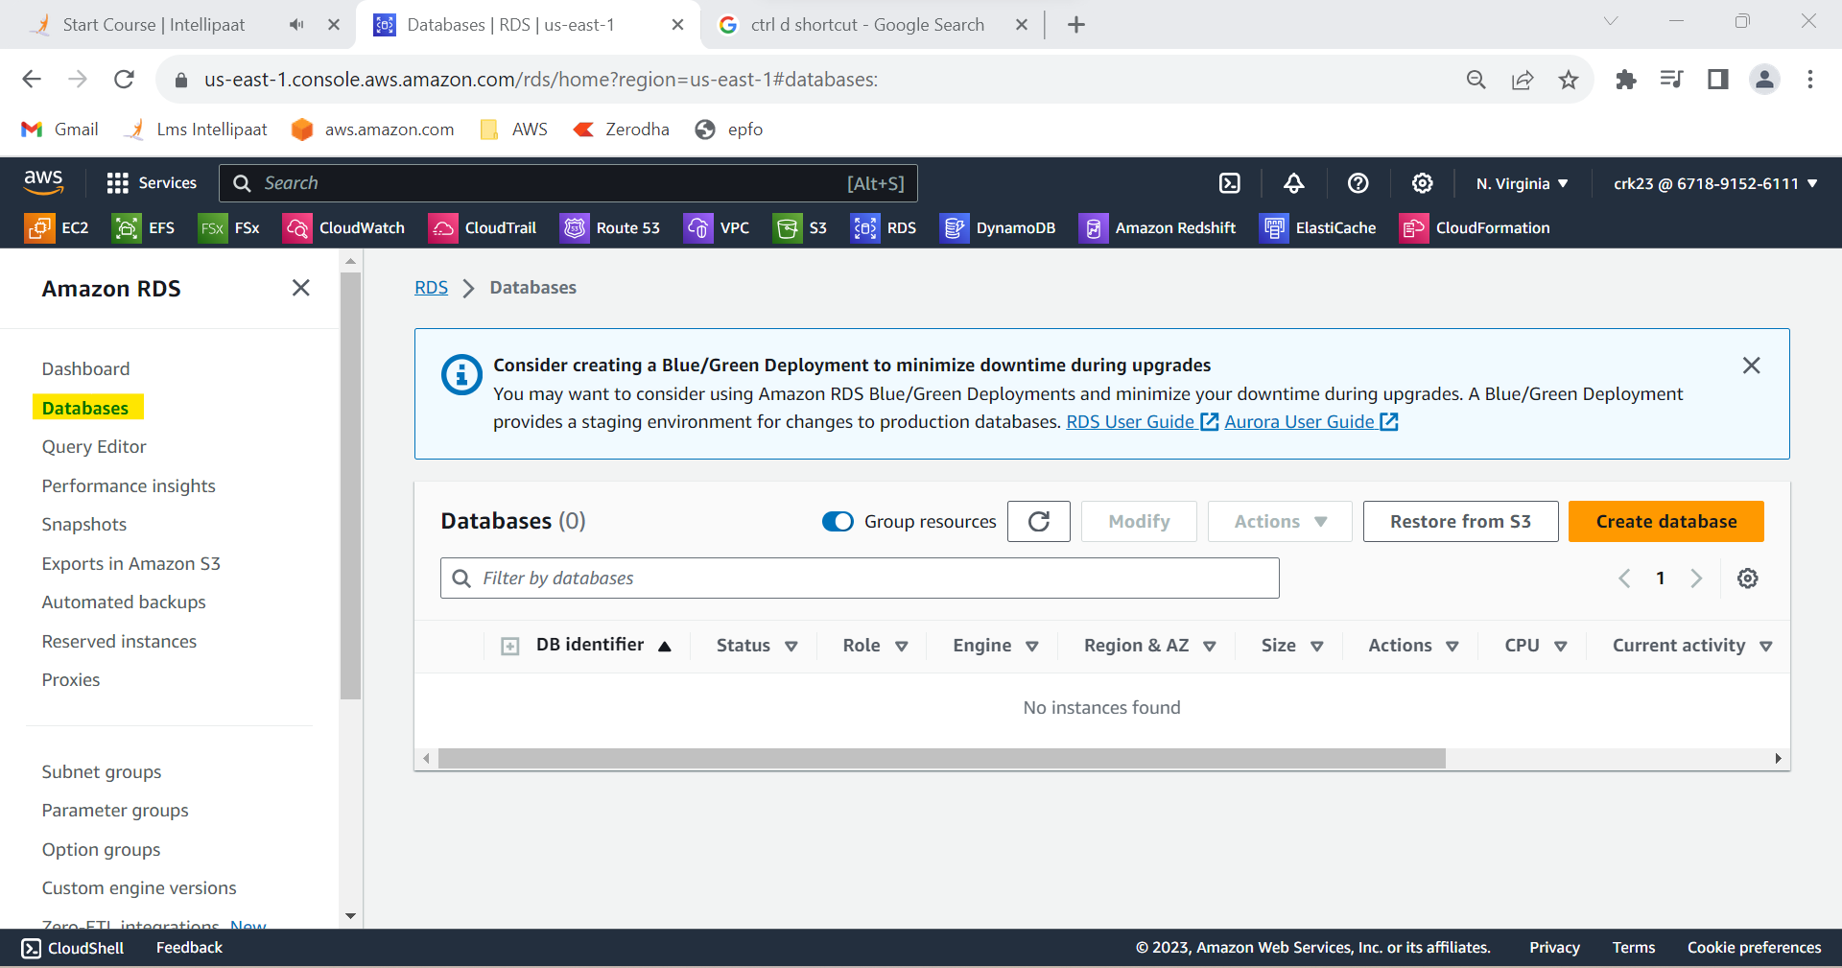

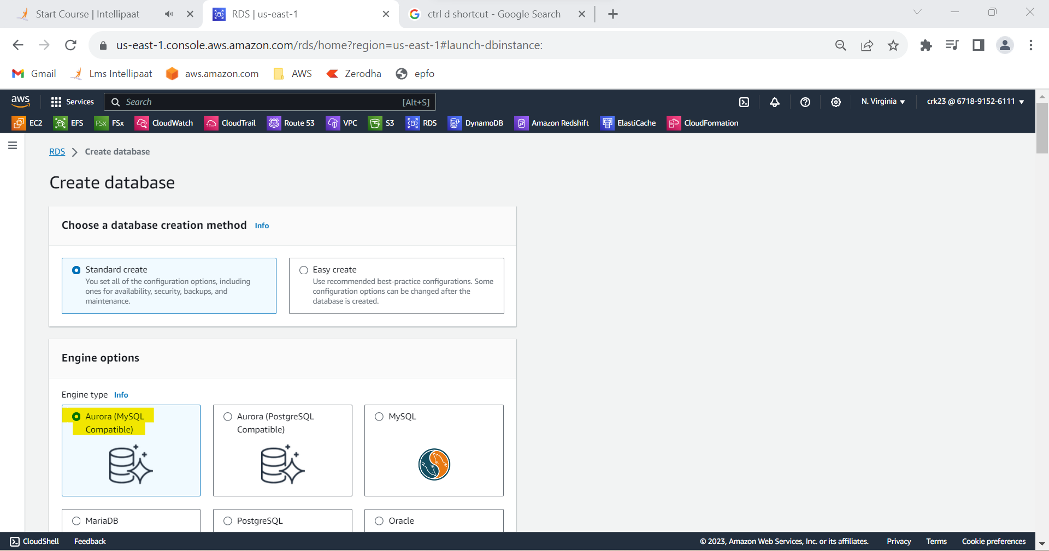

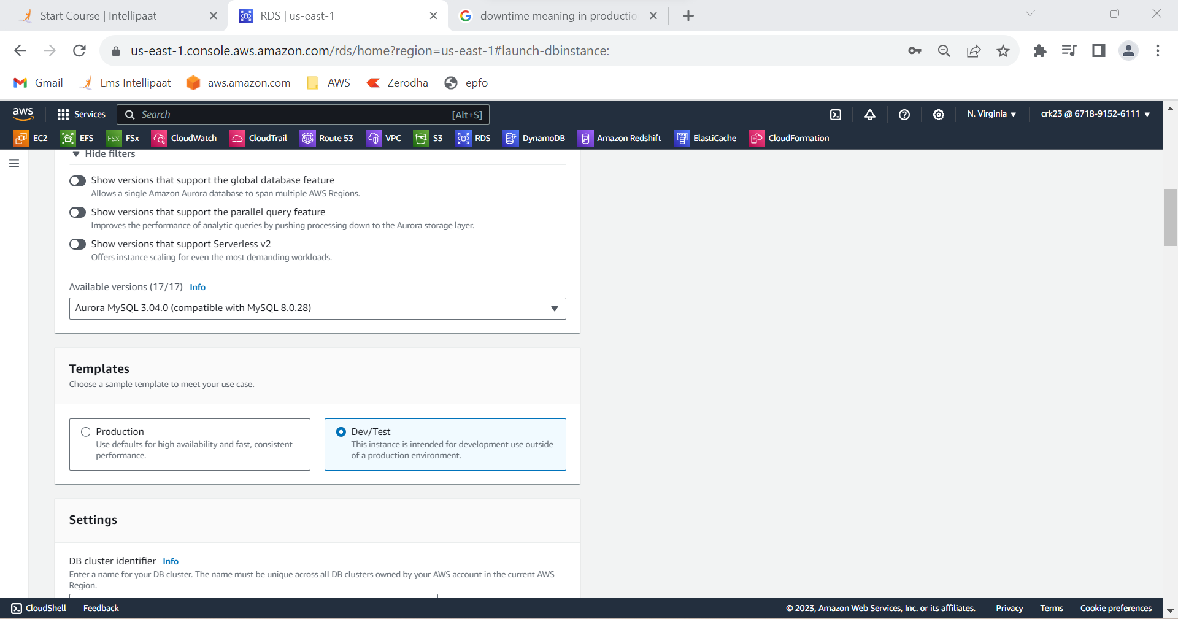

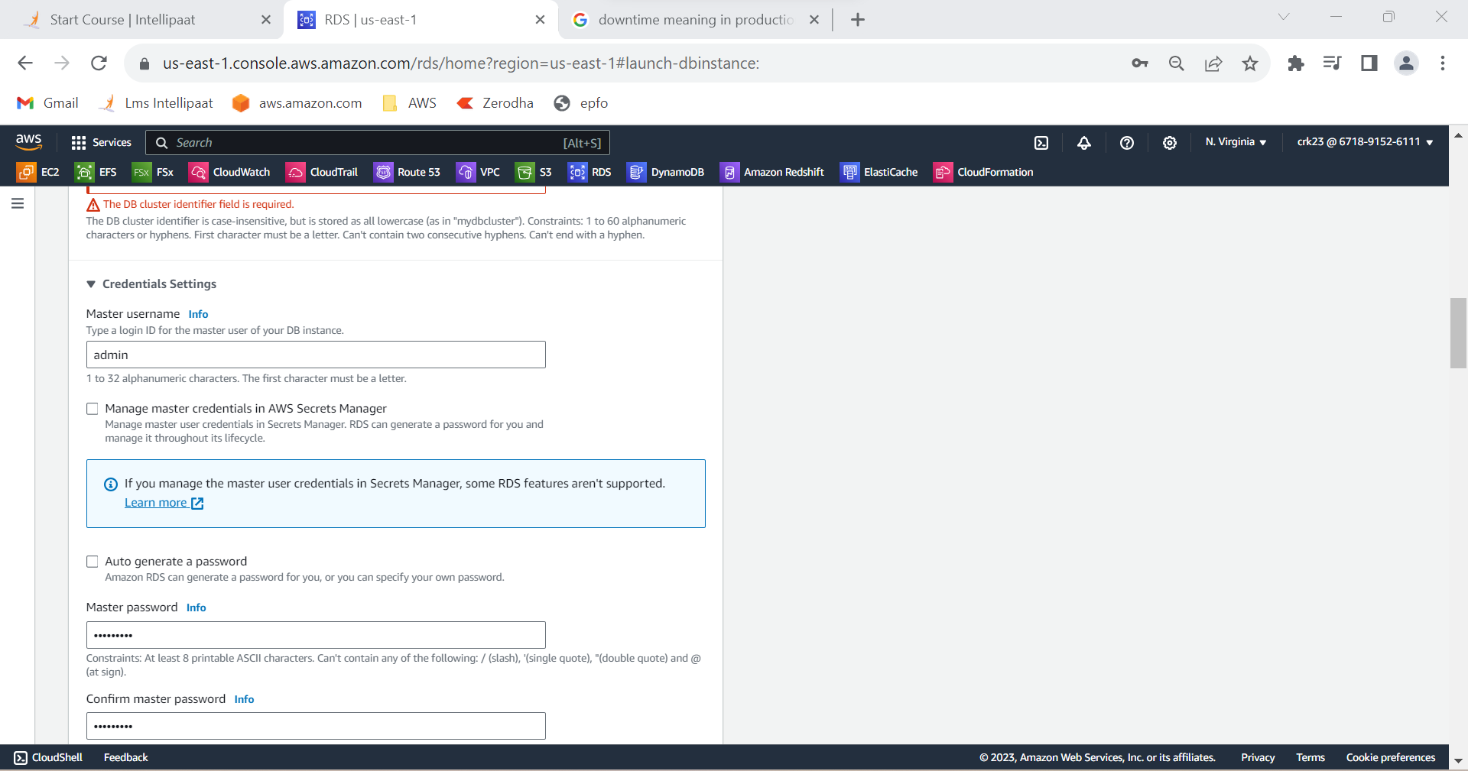

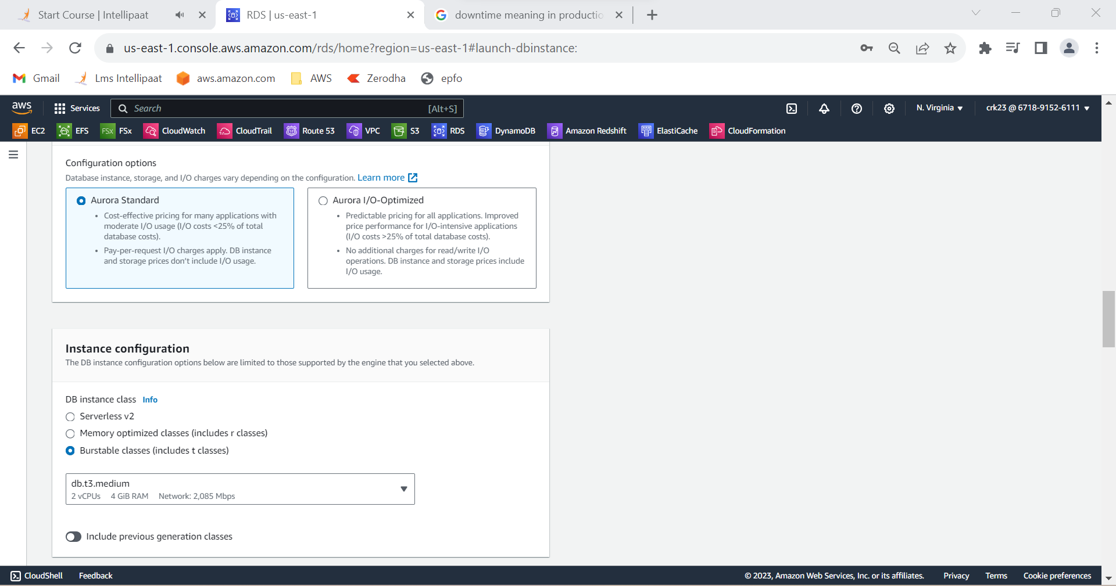

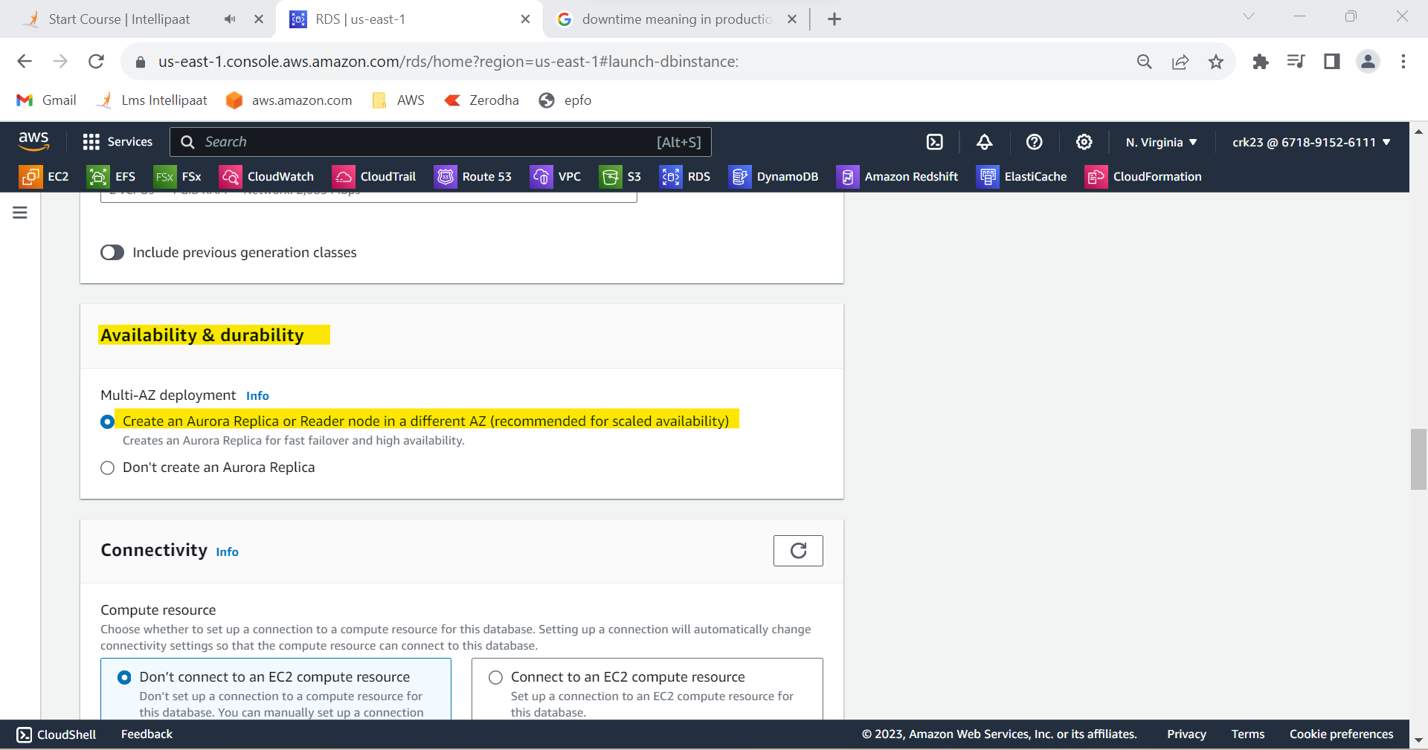

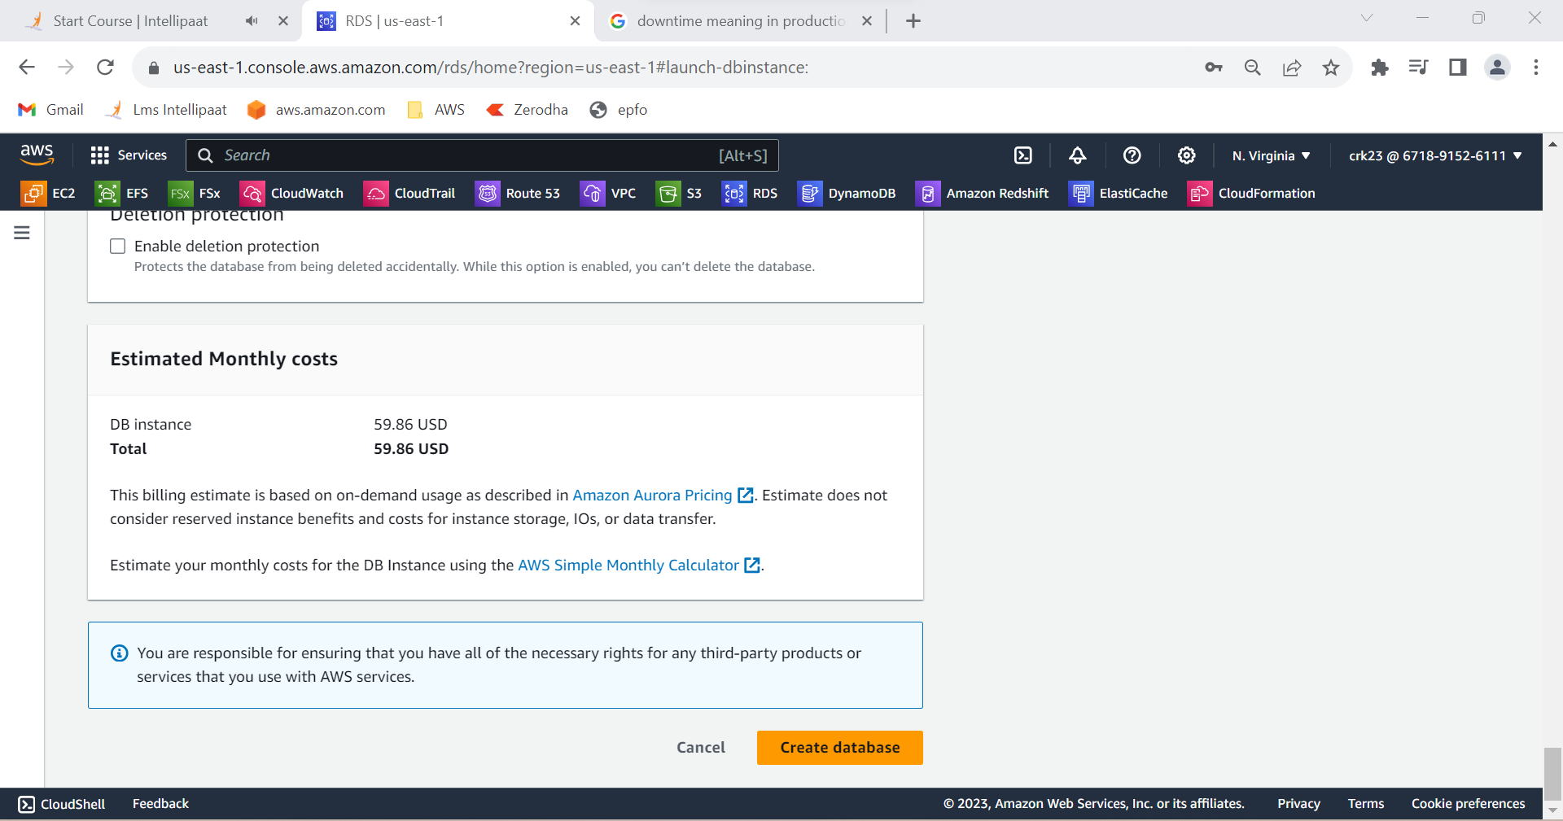

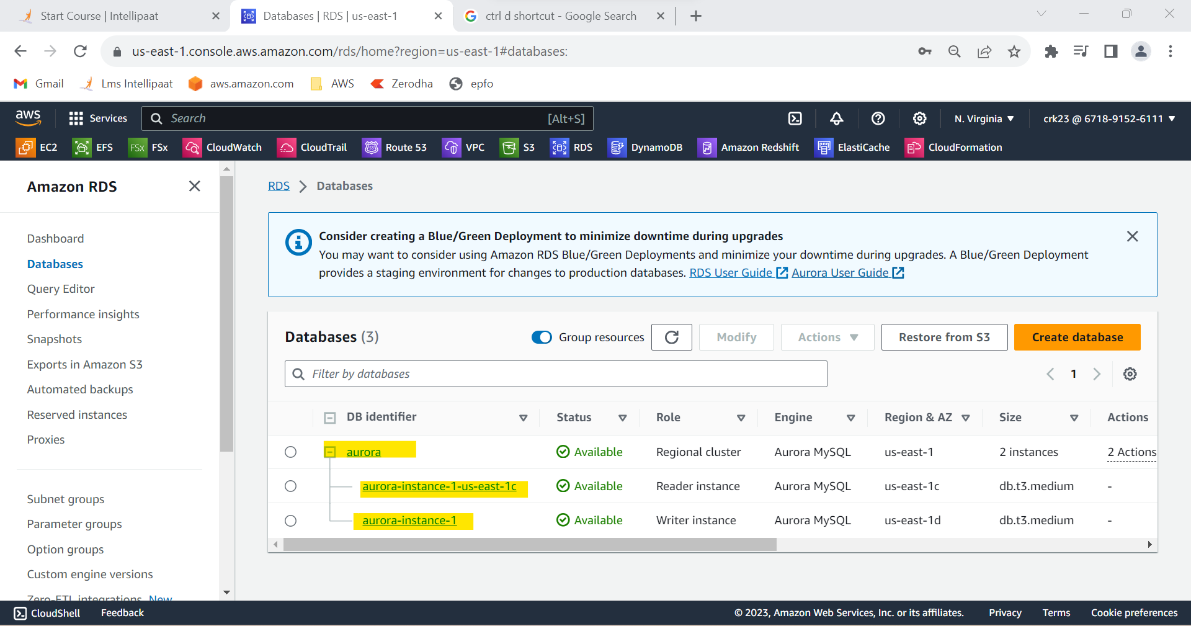

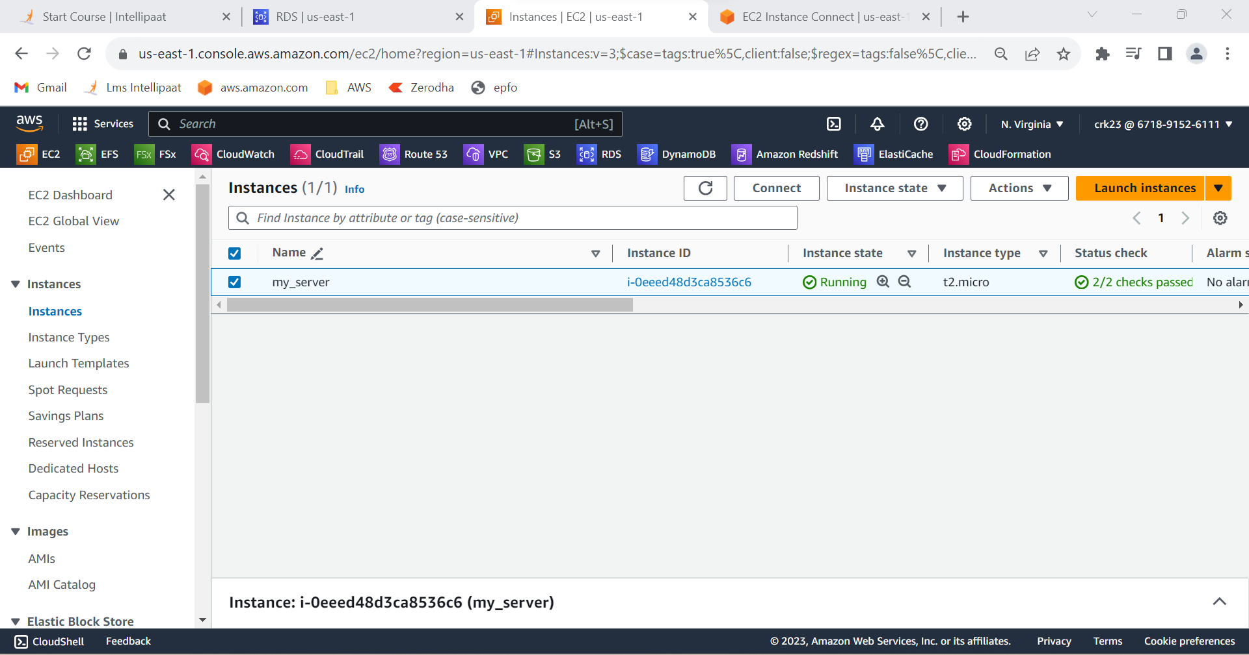

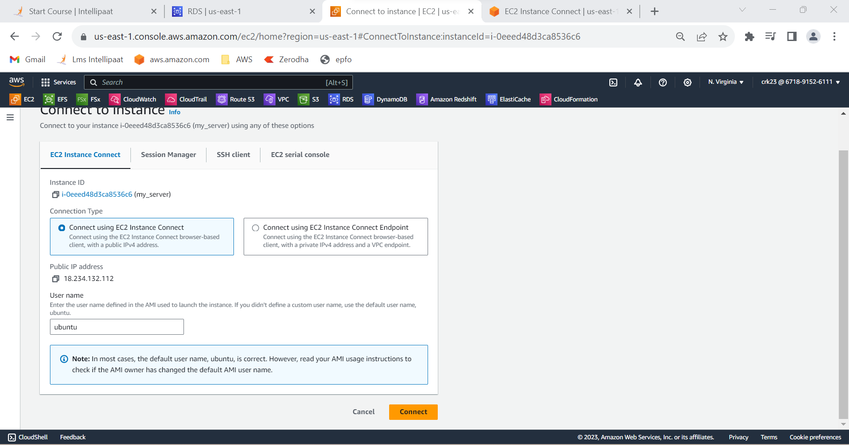

* Connect using writer endpoint

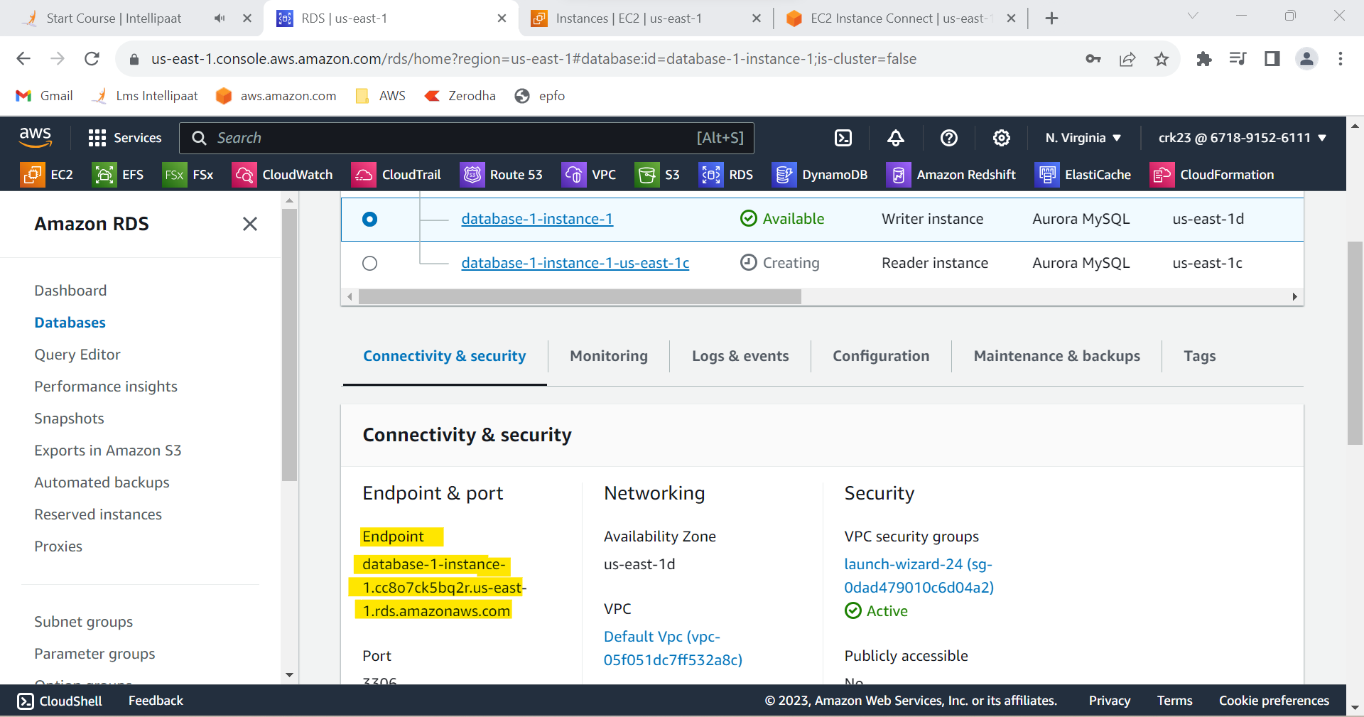

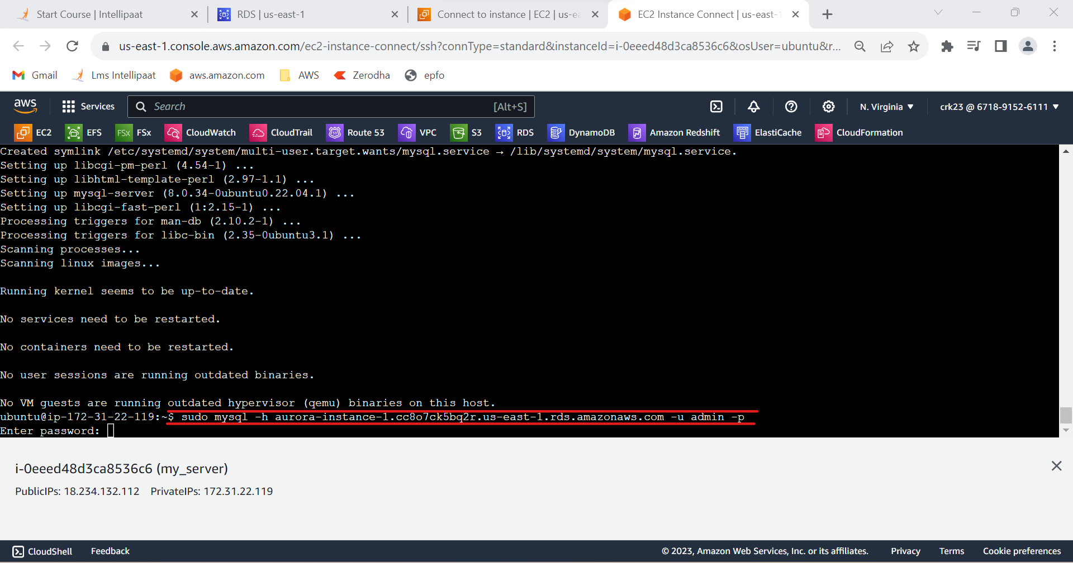

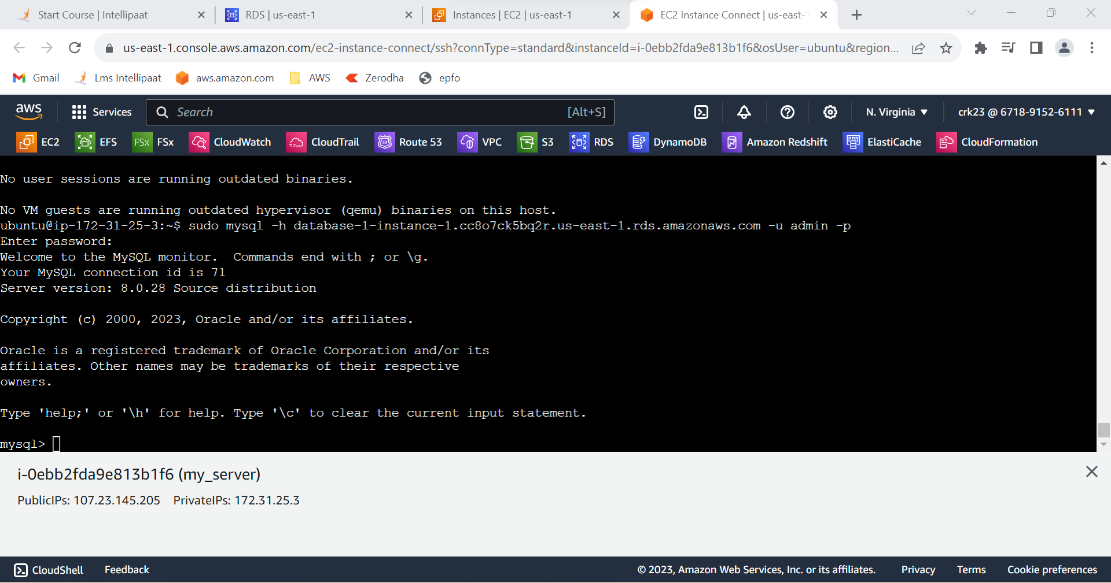

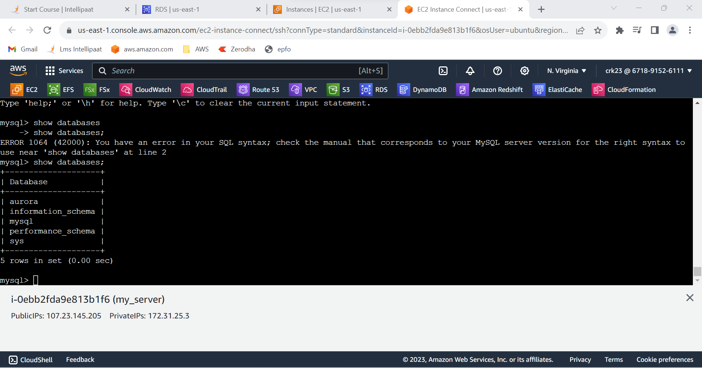

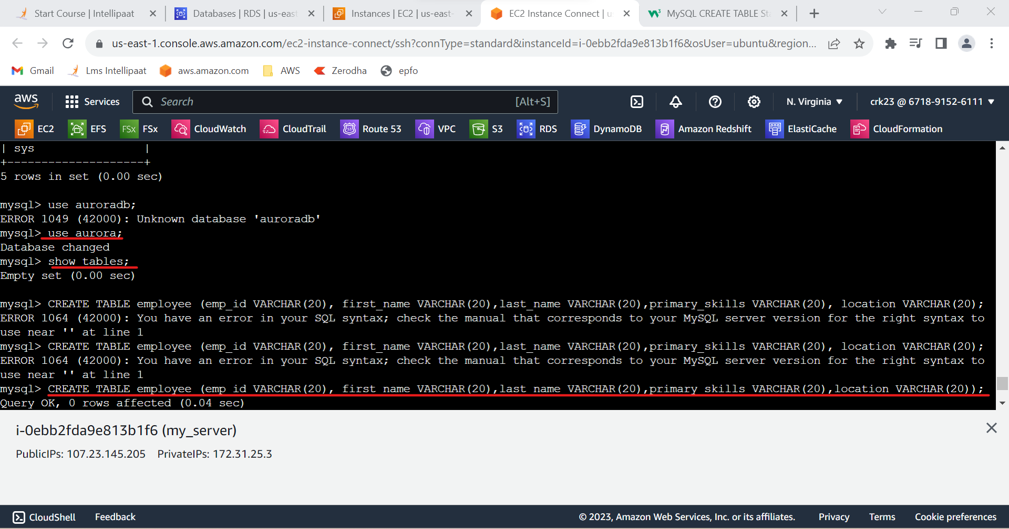

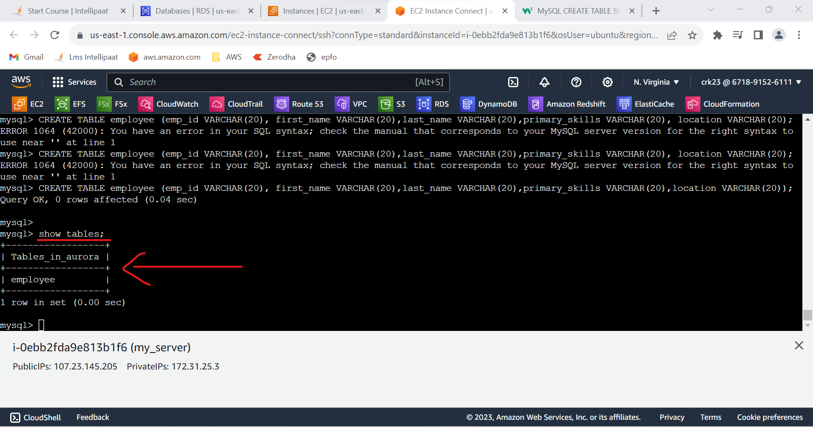

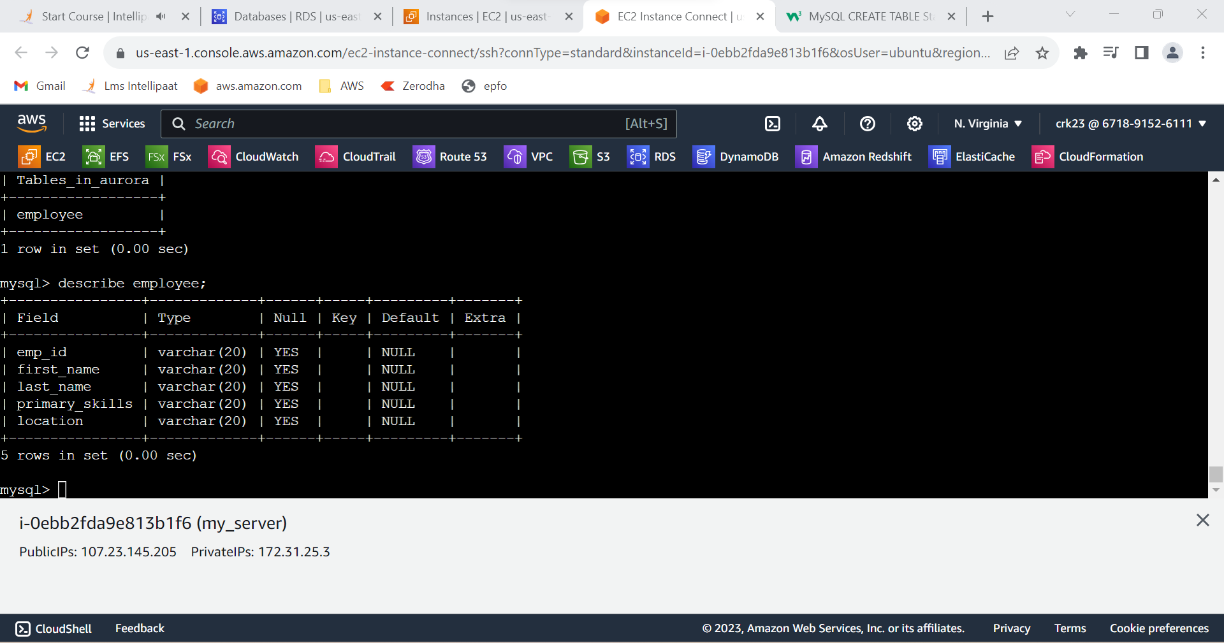

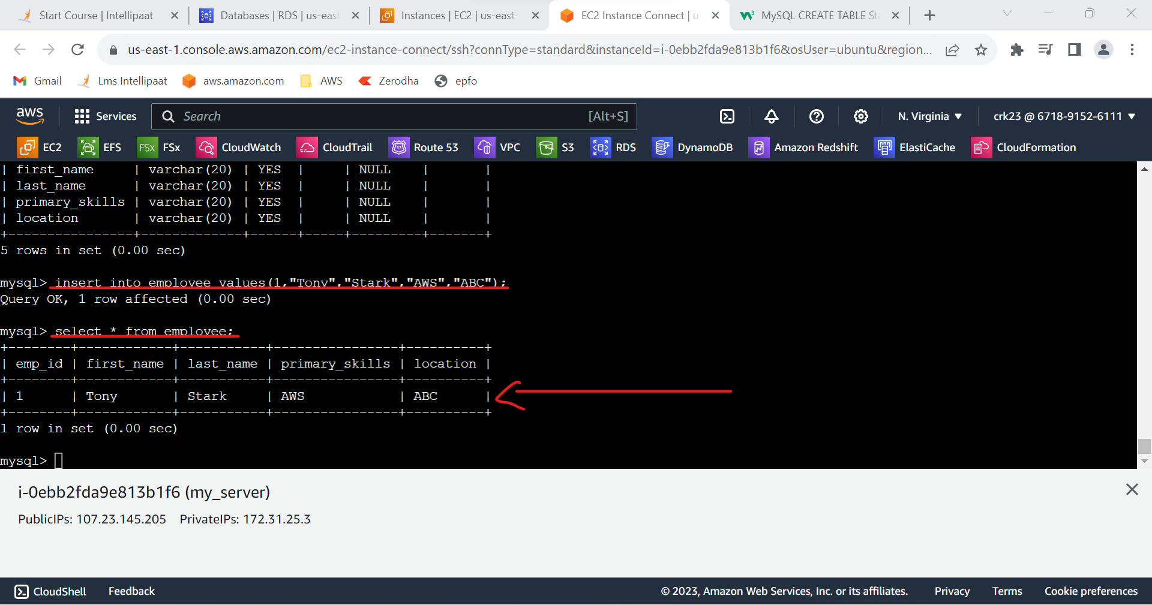

* Connect using reader endpoint

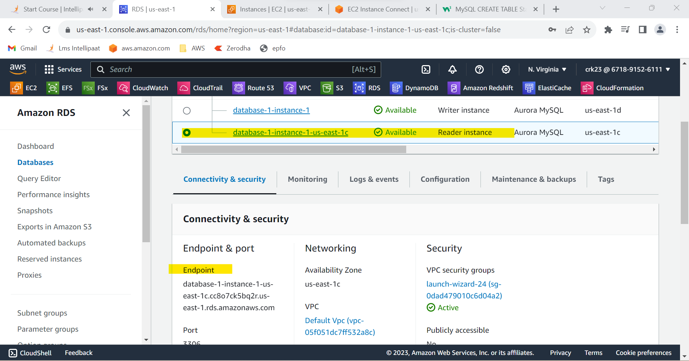

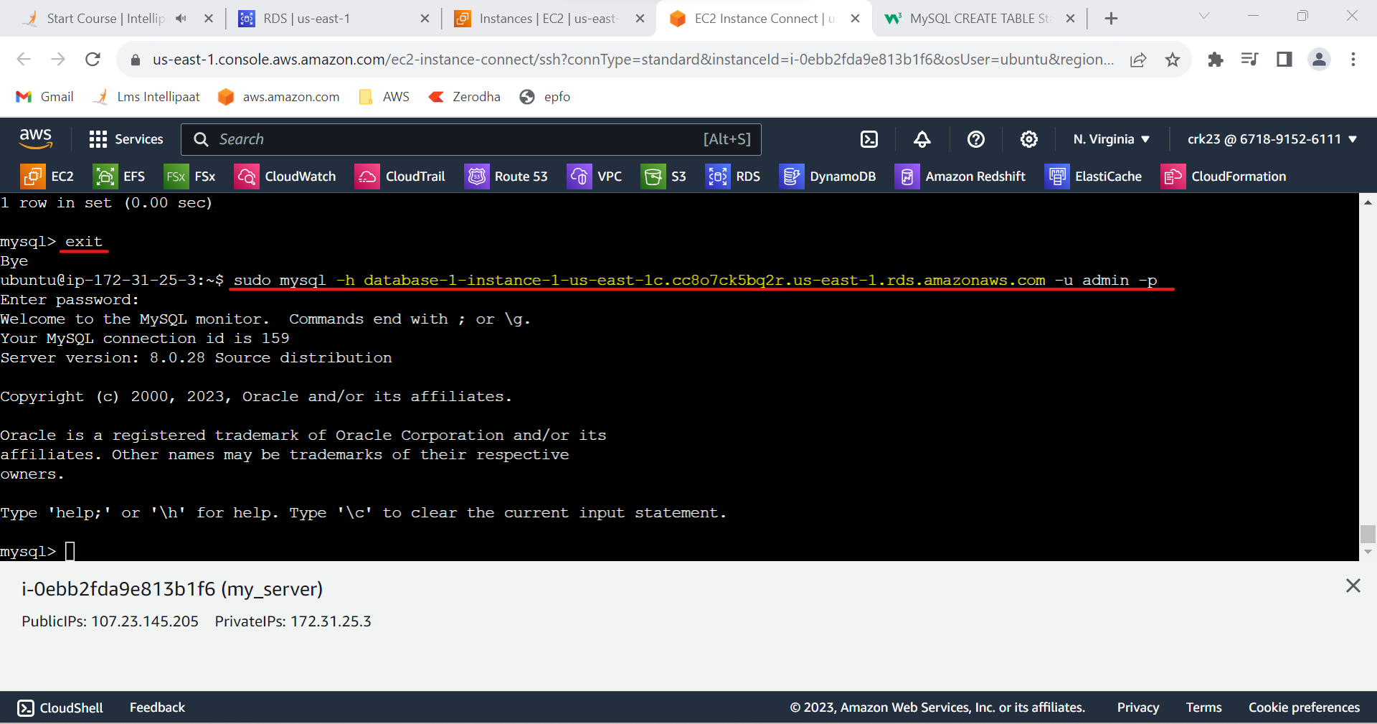

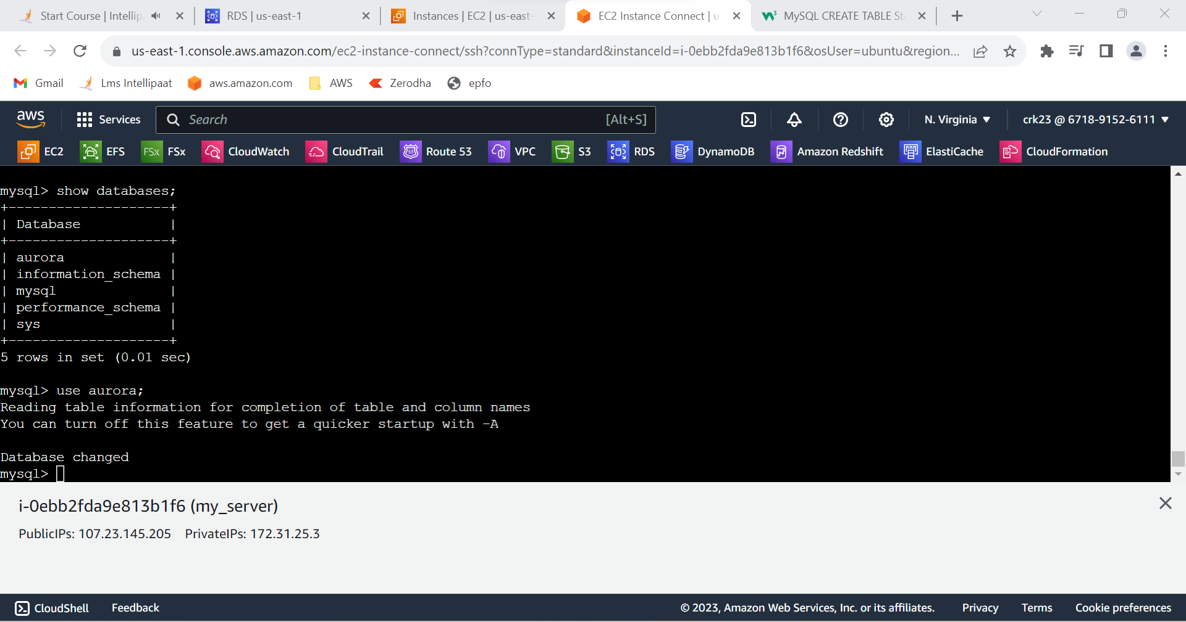

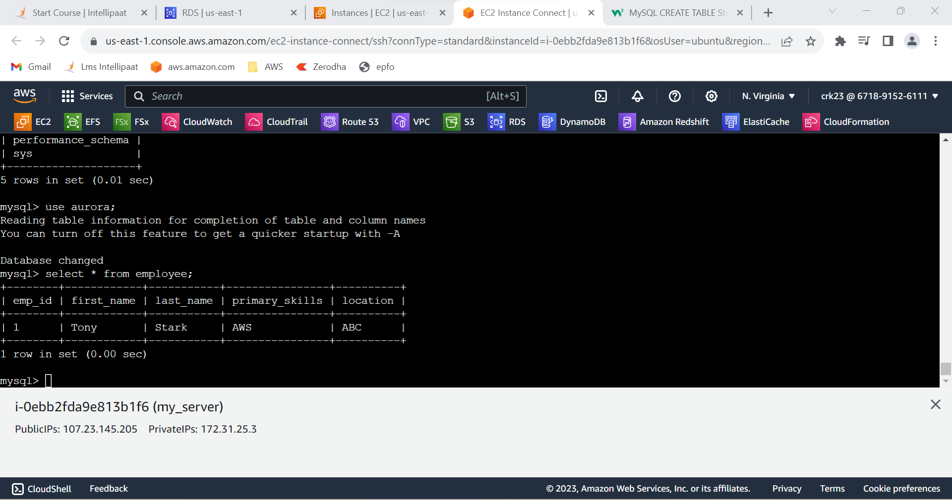

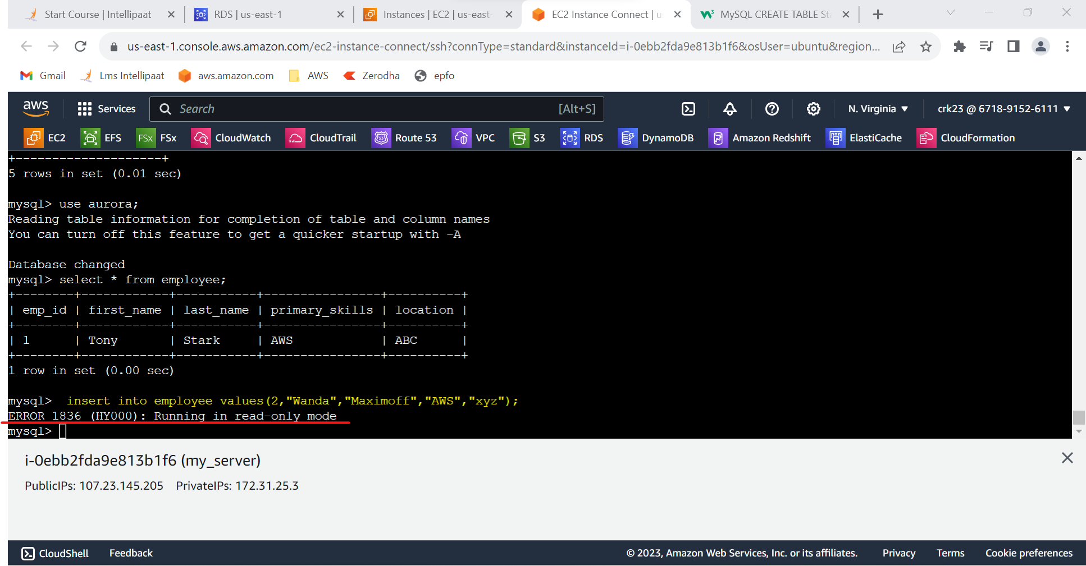

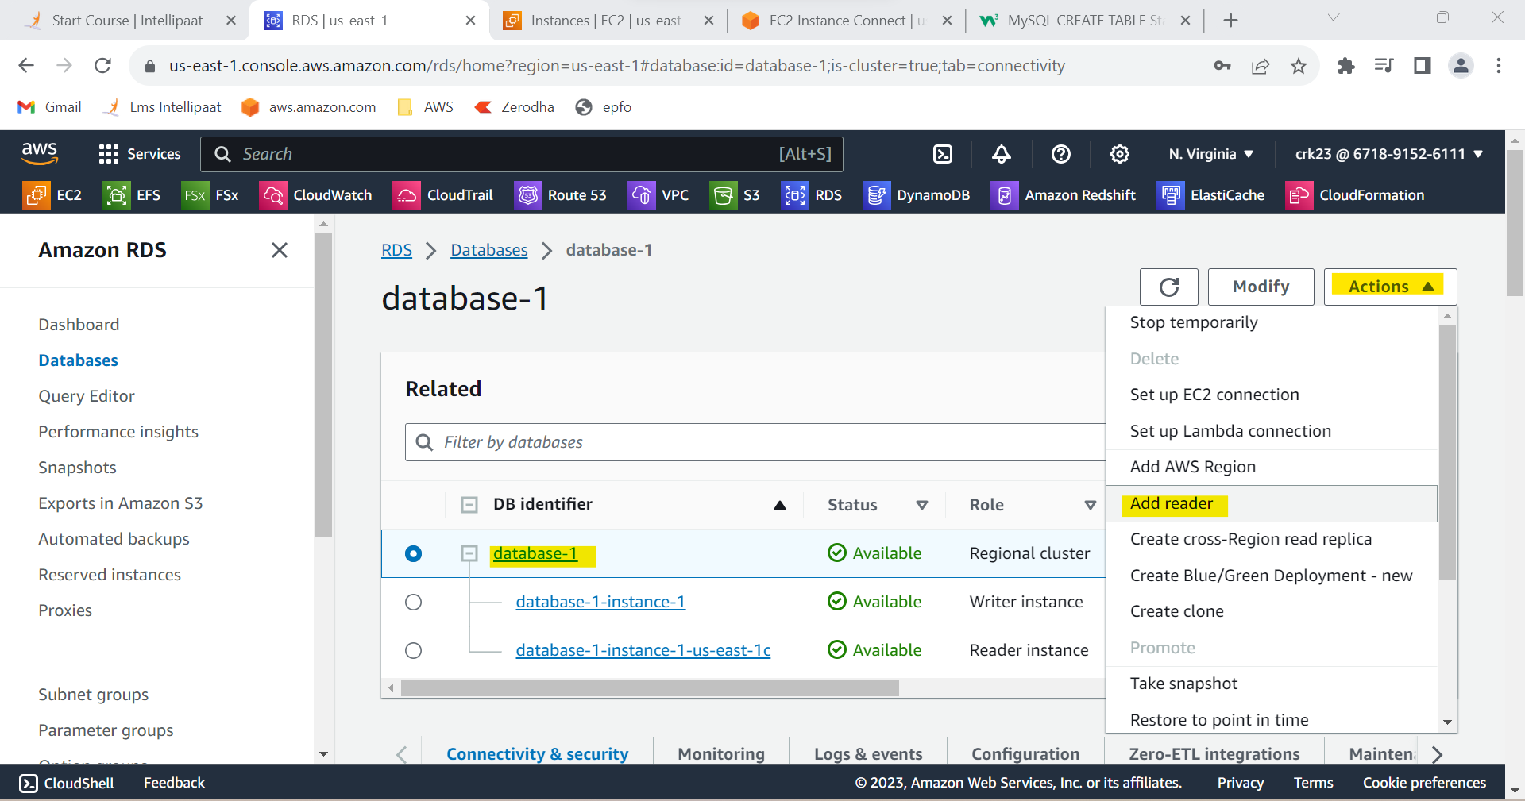

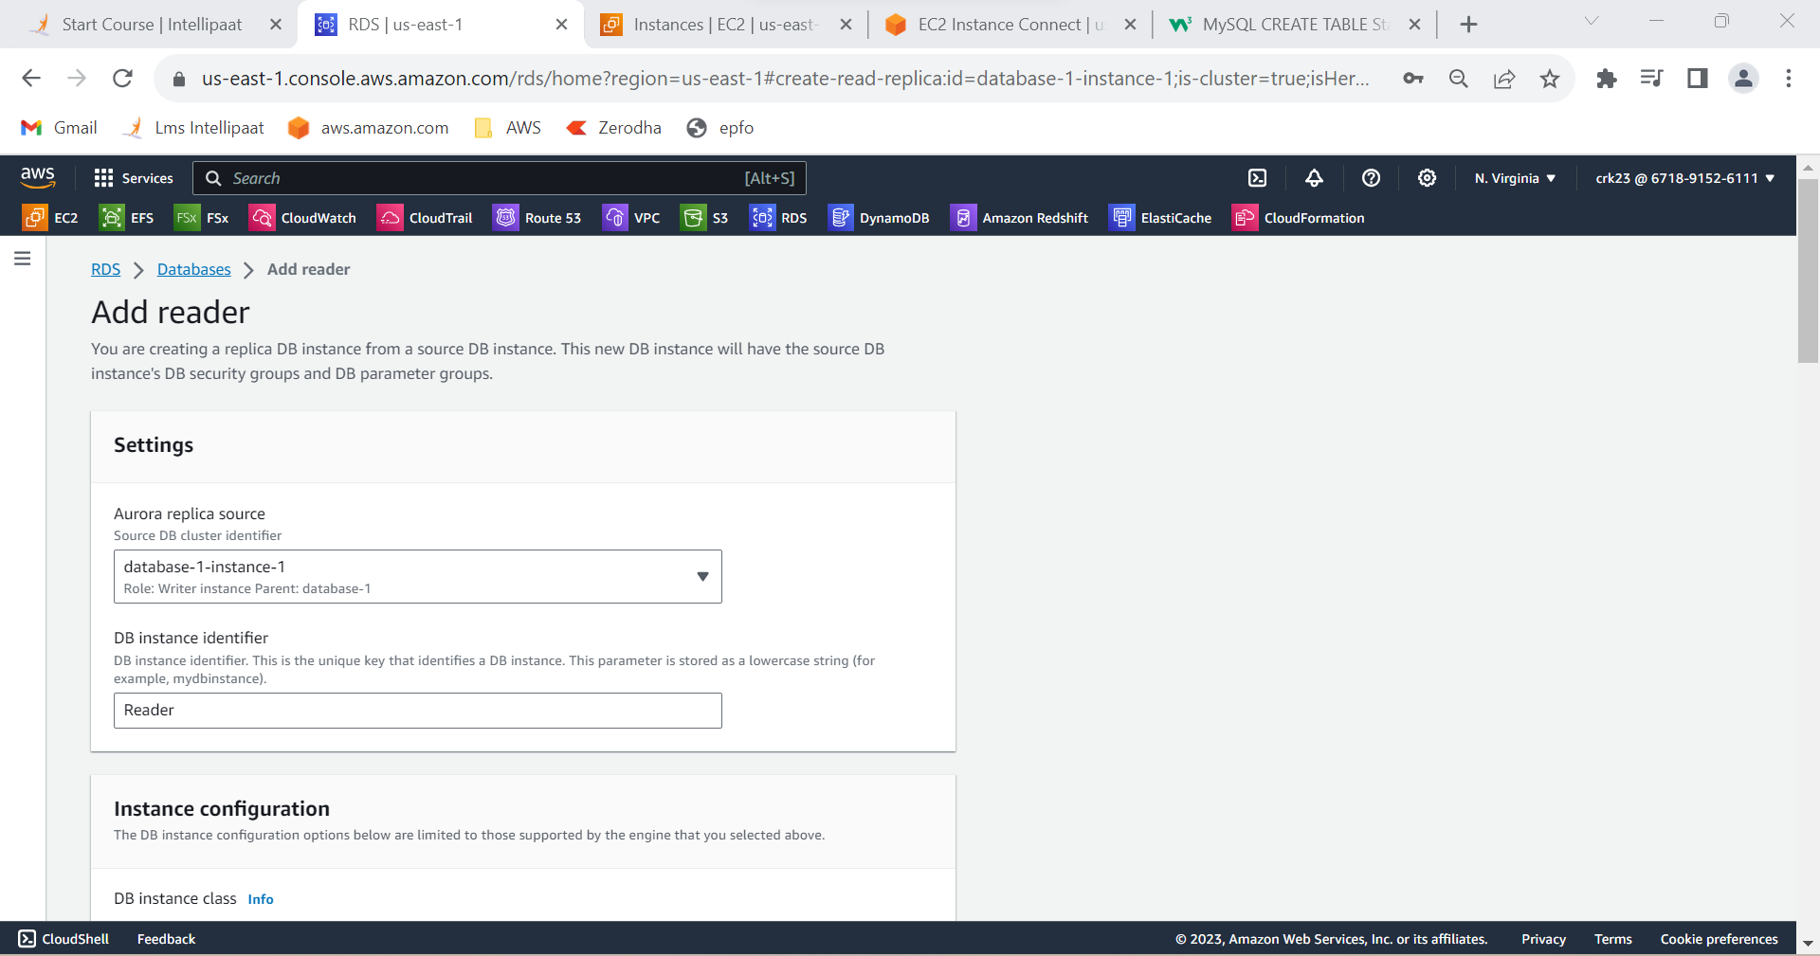

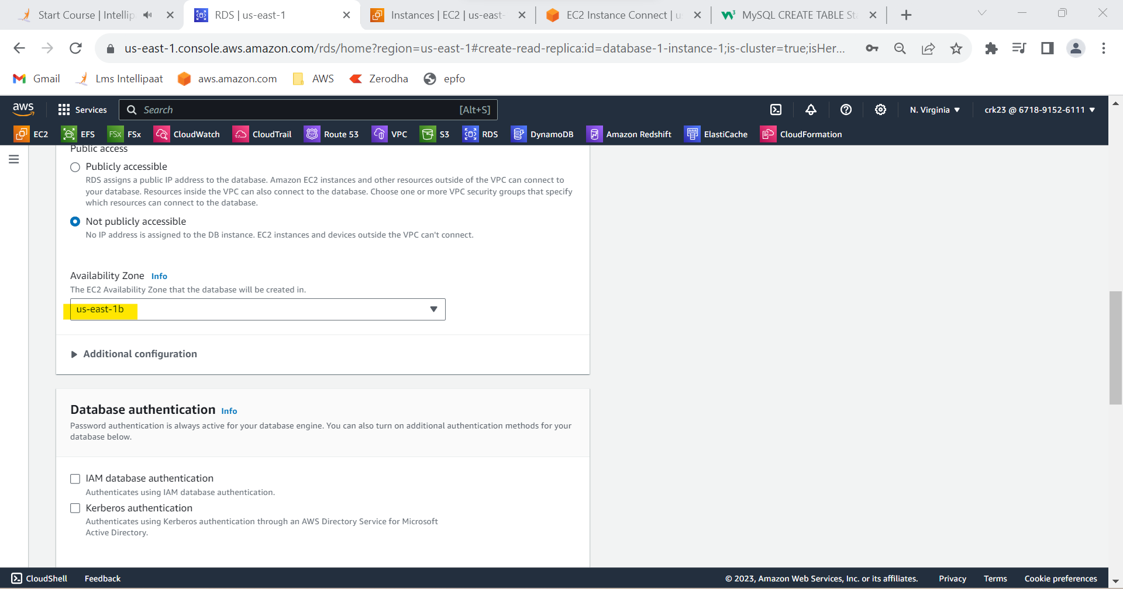

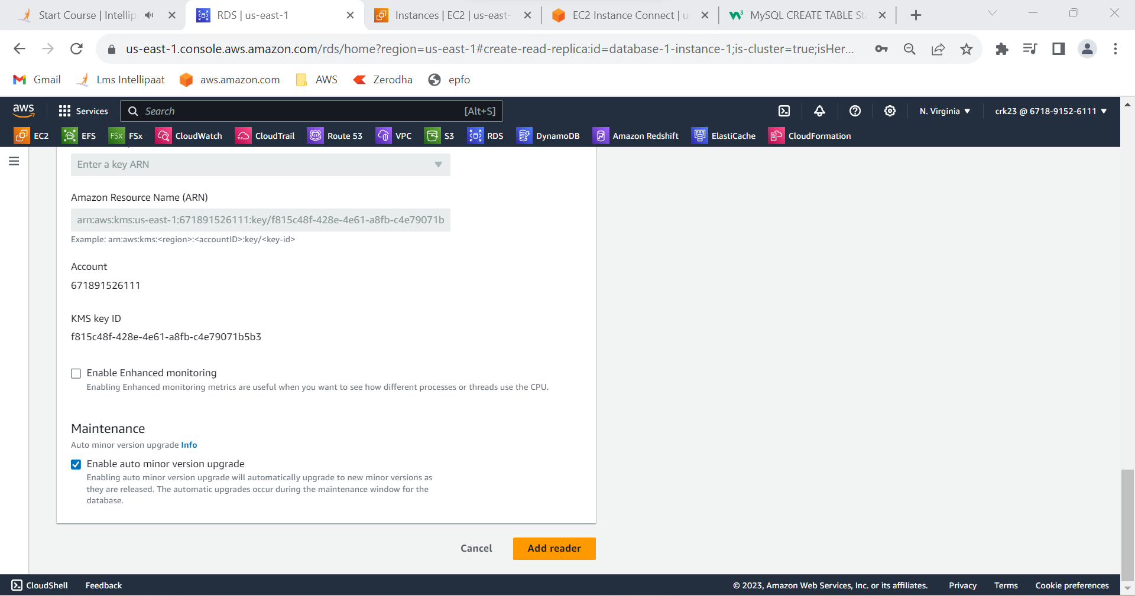

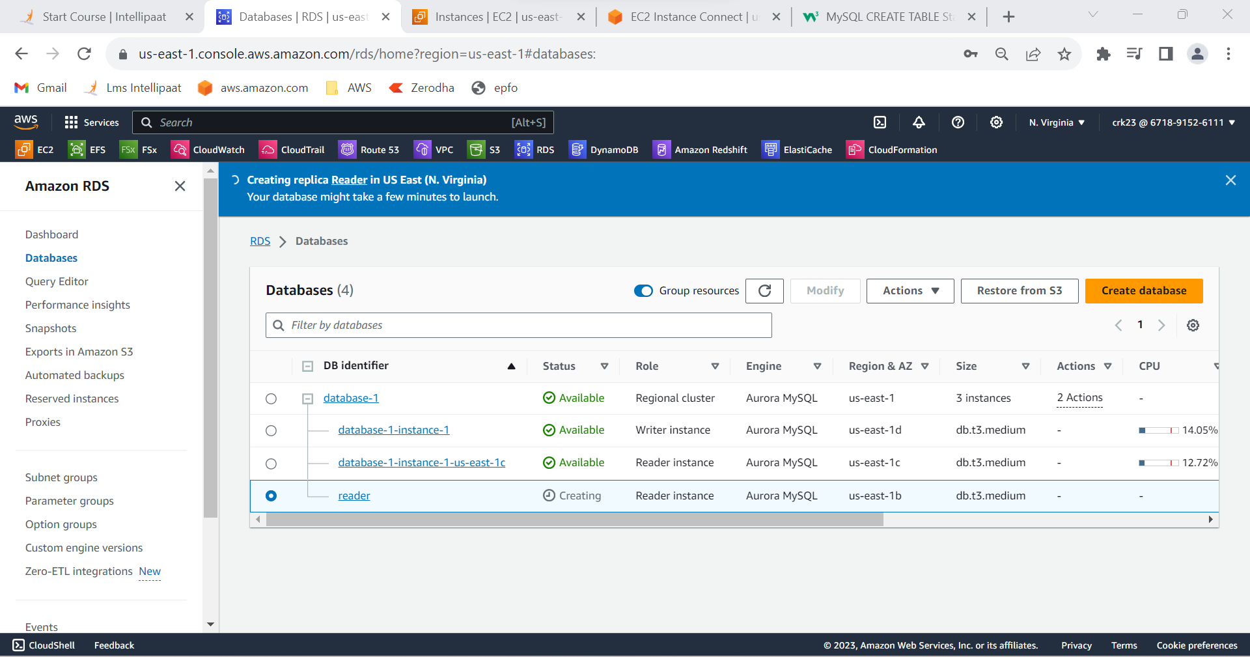

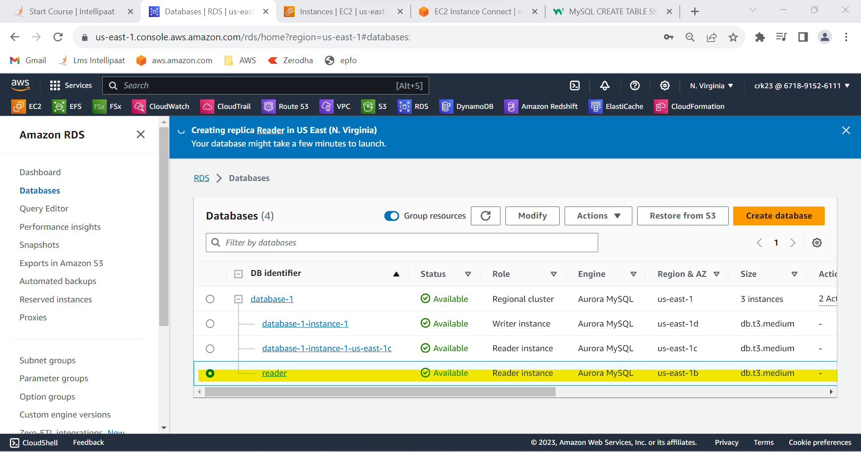

**OUTPUT:**

Created an AuroraDB Engine based RDS Database and replicated two read replicas in different availability zone.